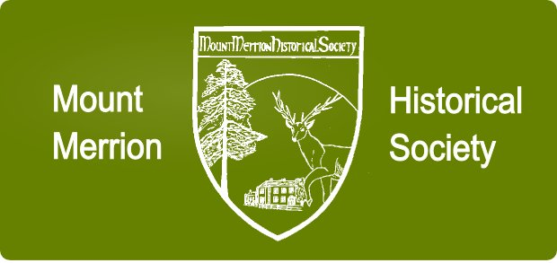
Memorabilia Evening
interesting items/articles displayed/presented by Members and Guests
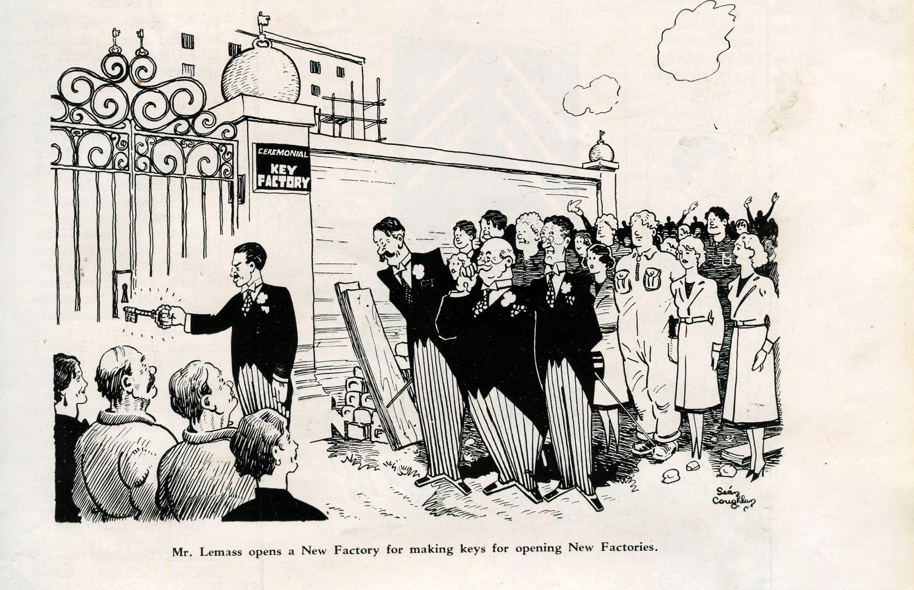
Dublin Opinion Cartoons
Constitutional, Housing, Political, Cultural
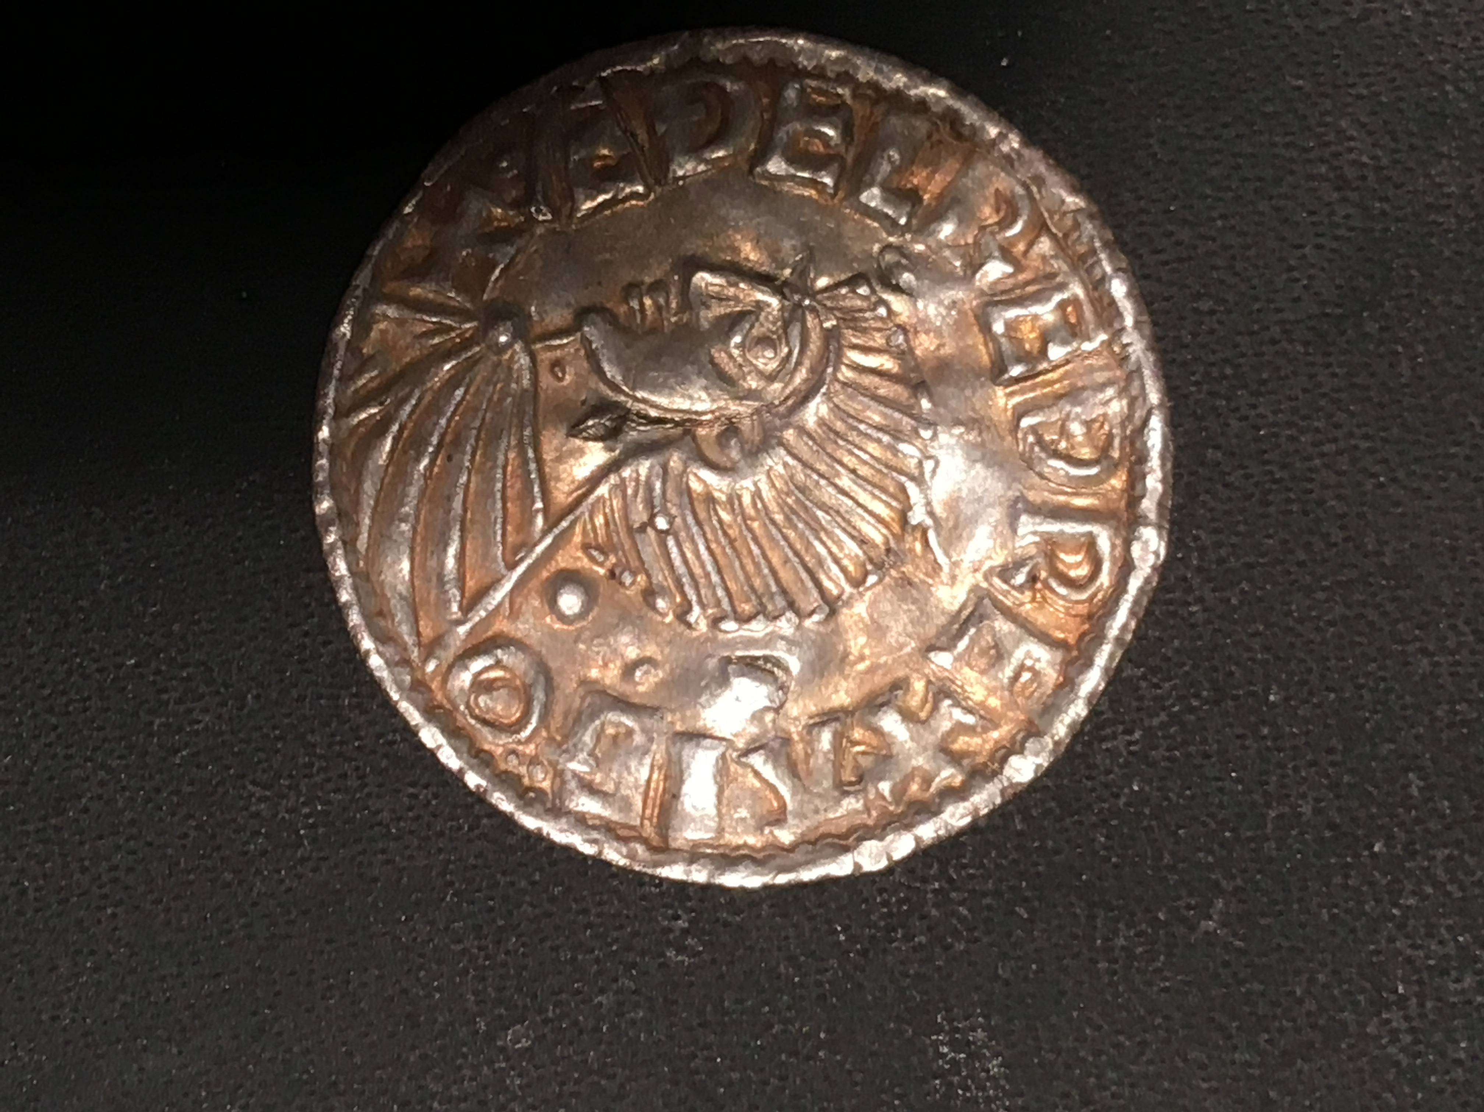
Irish Coins
Viking era to 17th century

+
* Terence Mac Swiney memorabilia
* UN photos and papers from 1960s
* Genealogical Society of Ireland
* and more
Each presenter will give a short talk on their subject and be available later with their paraphernalia on display
8.00pm, Thursday 7th December 2017
THE COMMUNITY CENTRE, MOUNT MERRION
Admission: Members No charge (see Season Membership)
Non-Members: €4.00 (Students €2.00)
Season 2017-18 Membership: €20 per person / €30 per couple
While the Society will endeavour to deliver the published agenda, lectures and speakers may be changed due to circumstances outside its control
email: mountmerrionhistoricalsociety@gmail.com web site: www.mountmerrionhistorical.com

