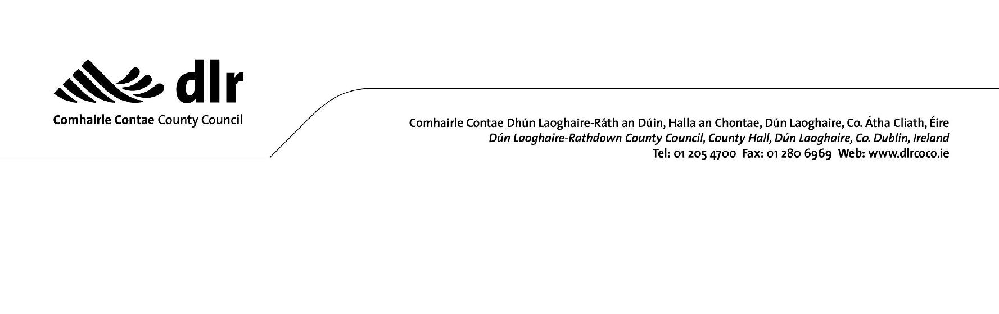

Environmental Complaints Form

Please e-mail completed form to wasteenforcement@dlrcoco.ie or post to the Environmental Enforcement Section, County Hall, Marine Road, Dún Laoghaire, Co. Dublin.

Complaint Type: | Air |  | Noise |  | Waste

Full details of incident giving rise to complaint (including time, date and duration of occurrence). Please note that details such as vehicle registration numbers are of particular assistance in complaint investigation. Additional information (e.g. maps, photos, etc.) may also be included if necessary.

Location of Site/Premises

Address: _________________________________________________________________

Complainant Details

Name: ____________________________________ Contact No.: ______________

Address: _________________________________________________________________

E-mail Address: ___________________________________________________________

Confidentiality

I request that DLR Co. Co. does not disclose my identity during its investigation of this matter

Signature: _______________________________ Date: ____________________

