Mount Merrion Historical Society

Outing to
Cavan Museum & Tullynally Castle
and its attractions
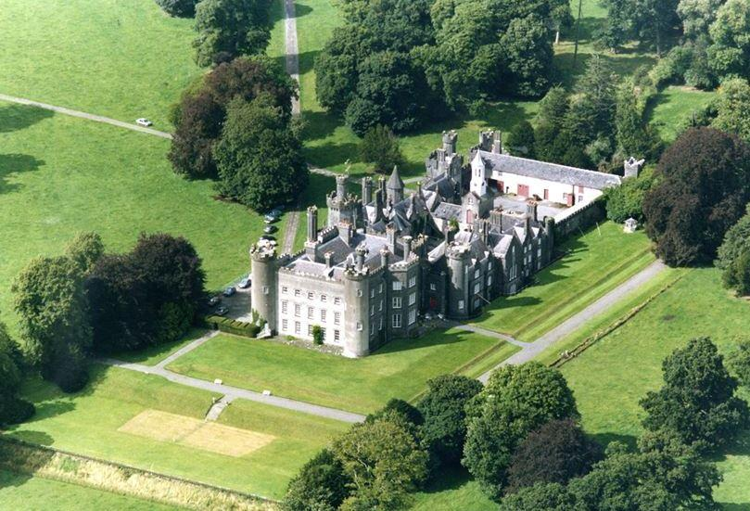
Saturday 9th June, 2018
Depart: Mount Merrion 9.00am
(from The Rise car park Church of St. Therese)
Return: Mount Merrion 5.45pm
Price: €39.50 per person
(includes coach trip, tea/coffee on arrival, guided tours)
Guided tours of:
Cavan Museum WW1 and GPO exhibits
Tullynally House (self-guided in Gardens)
see www.mountmerrionhistorical.com for more details
For details and bookings please contact:
Brendan McManus 0879072032
Evanna Kennedy 0868756969
Members and Non-members welcome

