Lt. Gen. Seán MacEoin
“Blacksmith of Ballinalee”
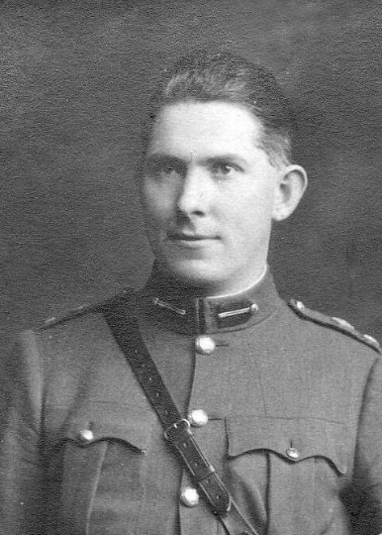
ILLUSTRATED TALK
by
John Murphy
8.00pm Thursday 4th Oct 2018
Lieutenant-General Seán MacEoin, (1893-1973) was born in Bunlahy, Co. Longford. He ran his father’s forge in Ballinalee, Co. Longford with his brother Michael after the unexpected death of his father in 1913. From such humble beginnings, his career was an incredible one, with Sean rising to national prominence during the War of Independence when he led the famous North Longford Flying Column. He was part of a revolutionary generation who by their actions laid down the foundation of this state.
Sean MacEoin, by his deeds both on and off the battlefield, gave leadership when it was needed and did so in a chivalrous manner that was acknowledged by friend and foe alike. Whilst his most notable achievements were during the War of Independence, his career spanned 51 years. He rose to the rank of Chief of Staff of the Defence Forces in 1929 followed by a political career leading to two ministries in the first two interparty governments and presidential candidate on two occasions.
John Murphy, a native of Edgeworthstown, Co Longford now resident with his wife and family in Moate, Co. Westmeath, is a grand nephew of General Seán MacEoin. He is the author of the website www.seanmaceoin.ie and has had a keen interest in Seán MacEoin since early childhood. John is a graduate of Athlone Institute of Technology where he graduated with a BSc. Polymer Technology. He has worked in management and technical roles for 26 years in the Irish Manufacturing sector.
THE COMMUNITY CENTRE, MOUNT MERRION
Admission: Members No charge (see Season Membership)
Non-Members: €4.00 (Students €2.00)
Season 2018-19 Membership: €20 per person / €30 per couple
While the Society will endeavour to deliver the published agenda, lectures and speakers may be changed due to circumstances outside its control
email: mountmerrionhistoricalsociety@gmail.com web site: www.mountmerrionhistorical.com

