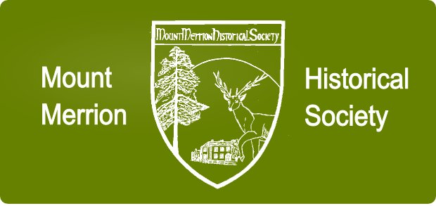
SEASON 2018-2019
Date | Topic | Presenter
04-Oct-18 | Gen. Sean Mac Eoin  the blacksmith from Ballinalee | John Murphy
01-Nov-18 | UCD and the development  of the Belfield Campus | Ruth Ferguson
06-Dec-18 | Comhaltas Ceoltori Eireann:  Ceol agus Craic | Siobhán ní Chonaráin
03-Jan-19 | Stanley Woods  world’s first motorcycling superstar | David Crawford
07-Feb-19 | Frank Aiken: International Statesman and External Affairs Minister | Dr. Stephen Kelly
07-Mar-19 | Admiral Richard Brydges Beechey  Maritime Artist | Cormac Lowth
04-Apr-19 | Ballycorus Lead Mines | Rob Goodbody
02-May-19 | The Amazing Life of Delia Murphy | Carmen Cullen
8.00pm, COMMUNITY CENTRE, MOUNT MERRION
Admission: Members: No charge (see Season Membership)
Non-Members €4.00 (Students €2.00)
Season 2018-19 Membership: €20 per person / €30 per couple
While the Society will endeavour to deliver the published agenda, lectures and speakers may be changed due to circumstances outside its control.
email: mountmerrionhistoricalsociety@gmail.com
web site: www.mountmerrionhistorical.com

